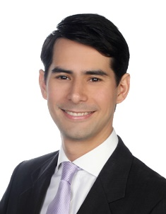Name

**Phone** :

**Emai**[**l** :](mailto:l%20%20%20%20%20%20%20%20:%20adamfahim@gmail.com)

**Address** :

**LinkedIn** :

**Education**

1. **Universiti Teknologi Malaysia (UTM) – CGPA: 3.75 (2021)**

*Bachelor of Mechanical Engineering*

*Dean’s Award with First-Class Honours*

1. **Kolej Matrikulasi Melaka (2017)**

*Science Course (Modul 1)*

1. **Maktab Rendah Sains Mara Tun Ghafar Baba (2015)**

*Sijil Pelajaran Malaysia (SPM)*

**Work Experience**

1. **Company Name** **(November 2021-Present)**

*Position Name*

* 1. Perform
  2. Conduct
  3. Ensure
  4. Manage
  5. Supervise

**Achievements**

1. Successfully
2. Reduced
3. **Company Name (March 2021- July 2021) (5 months)**

*Position Name*

* 1. Analysed
  2. Monitored
  3. Conducted
  4. Designed
  5. Performed

**Achievements**

1. Improved
2. Discovered

**Core Competencies**

**Project Management**

* Planning
* Budgeting
* Data Analytics

**Engineering**

* Matlab
* AutoCAD
* Solidworks

**Computer Skills**

* Microsoft Word
* Microsoft Excel
* Microsoft PowerPoint

**Highlighted Projects**

1. **Project Title (2020)**
   1. Handled
2. **Project Title (2019)**
   1. Proposed
3. **Project Title (2018)**
   1. Directed

**Achievements**

**Academic and Co-curricular Awards**

1. Achievement **(2020)**
2. Achievement **(2020)**
3. Achievement **(2019)**

**Leaderships**

1. **Event, Position (2020)**
2. Negotiated
3. Prepared
4. **Event, Position (2019)**
   1. Achieved
   2. Managed
5. **Event, Position (2018)**
   1. Structured
   2. Organized

**Special Certificates & Courses**

**Certificates**

1. Certificate
2. Certificate
3. Certificate
4. Certificate
5. Certificate

**References will be given upon request**